Assessment Report

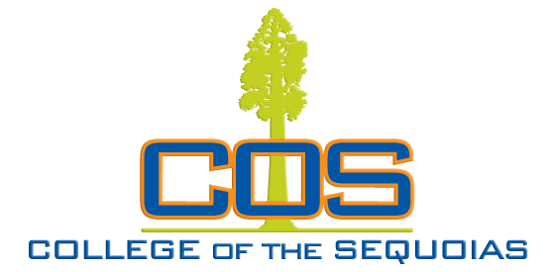

**Assessment Report**

Governance (Committee) - Equity, Diversity, and Action

Governance (Committee) - Equity, Diversity, and Action: Assessment Report

Governance (Committee) - Equity, Diversity, and Action: Assessment Column Report

Initiative

**Initiative Name**:Professional Development and Heritage Events

**Initiative**:Engage in and Support Ongoing Professional Development and Heritage Events

**Initiative Status**:Active

**Academic Years**:2022 - 2023, 2023 - 2024

**Start Date**:09/14/2022

|  |
| --- |
| Result |
| **Result Date:** 05/01/2024  **Results:** Event proposals continue to be submitted (see attached budget ledger). Professional Development work group revises forms as needed, communicates regarding proposal review and approval, and provides support to applicants across the proposal process.  **Report Type:** Mid-Year  **Result:** Satisfactory  **Related Documents:**  [BudgetLedger-EDAC (1).pdf](https://reports.nuventive.com/report/26102569-f898-4076-8592-aa1243719d6c/link/4ef204ed-60be-4e28-bcef-a7eaabe91467/7J6j79aSOUck/BudgetLedger-EDAC (1).pdf)  **Actions**  **Follow-Up**  **Result Date:** 03/06/2023  **Results:** Events: a system has been established for subgroup review of event proposals. Projects: subgroup continues to meet as needed to review and rate project proposals.  Forms for both event and project proposals have been revised following feedback from committee members and area deans. Over half of available funds are currently committed to event and project activities.  **Report Type:** Mid-Year  **Result:** Carried Forward  **Actions**  **Follow-Up** |

Initiative

**Initiative Name**:Equity Website

**Initiative**:Create a website that centralizes resources for equity work and efforts.

**Initiative Status**:Active

**Academic Years**:2022 - 2023, 2023 - 2024

**Start Date**:09/14/2022

|  |
| --- |
| Result |
| **Result Date:** 05/01/2024  **Results:** Diversity, Equity, and Inclusion (DEI) website has been established and content has been added. Several tabs exist to disply information for students and COS employees (e.g. Chancellor's Office DEIA information, ASCCC IDEAA information, Equity Plan documents, Task Force information, Student Resources, etc). Website work group members continue to add to the website.  **Report Type:** Mid-Year  **Result:** Satisfactory  **Actions**  **Follow-Up**  **Result Date:** 03/06/2023  **Results:** The website committee has met and is gathering ideas for the content to be included on the website. The committee is also reviewing other schools with model equity websites.  **Report Type:** Mid-Year  **Result:** Carried Forward  **Actions**  **Follow-Up** |